Marc Cohen

Prof. Treanor

CSC 470

11 December, 2019

The game I made is called “Hospital Drift.” In this game, you drift your way through an icy, rocky, mountainous terrain on your way to a hospital. You better get there in time though, your patient’s life depends on it!

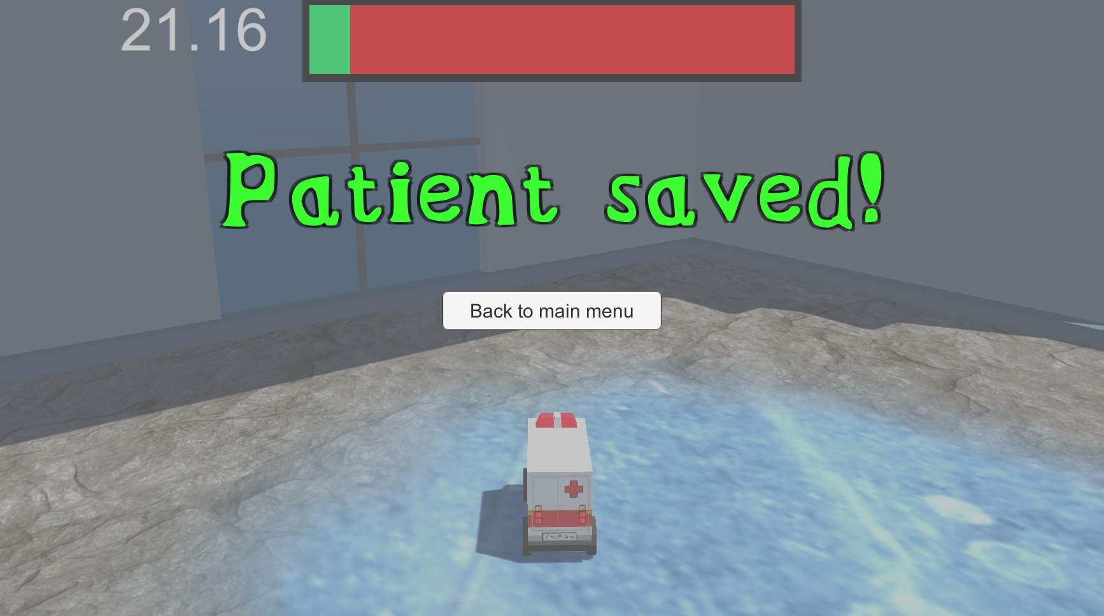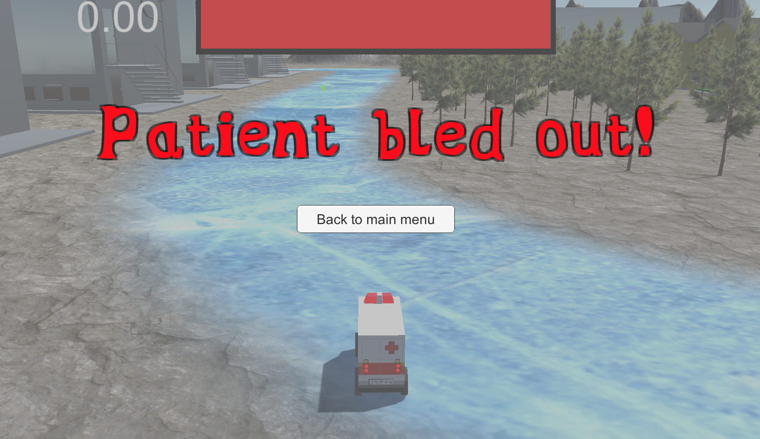

If you’re accustomed to typical racing game controls, “Hospital Drift” will throw you for a loop, as the ambulance you steer can easily drift out of your control if you don’t practice on your driving skills (hint: learn to use the brake to stabilize and control your ambulance around corners). With the ability to go forward, left, right, backwards, and brake, you have all the controls you need to save your patient in time. 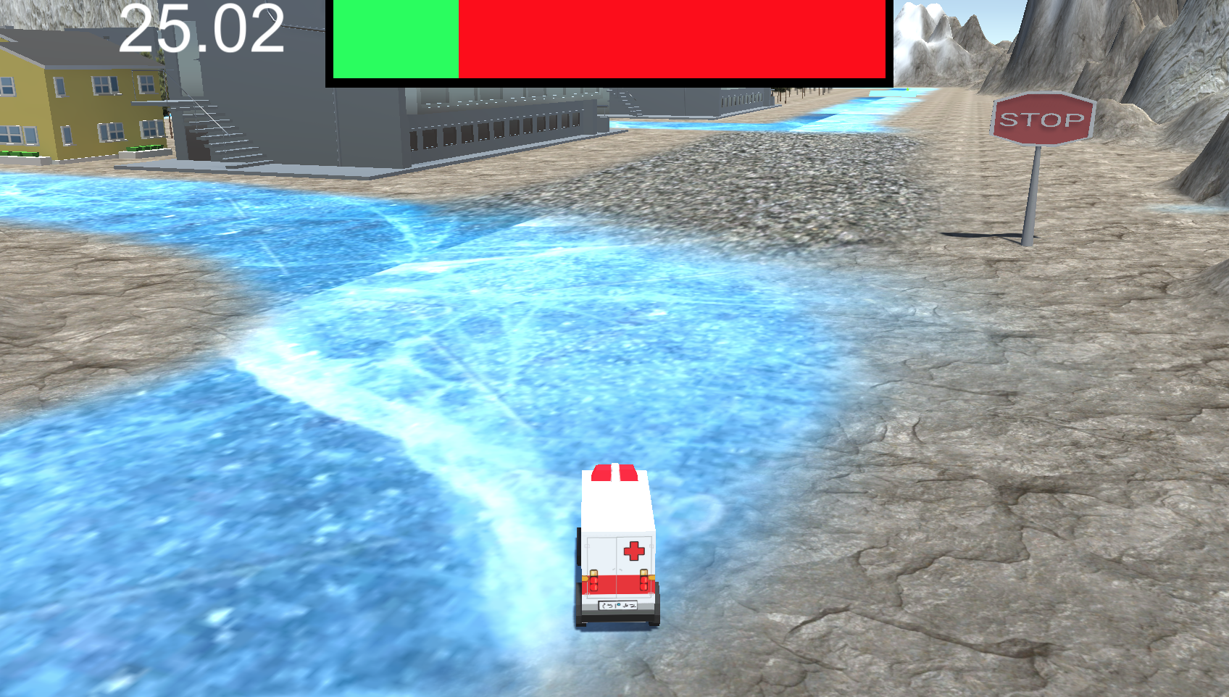

Seem hard? Start on the easiest difficulty, “Urgent.” Here, you have 110 seconds to navigate around the mountains, buildings, and trees to reach the hospital in time. There are various health gems spread throughout the map. Prioritize picking these up if you feel pinched for time! Want a challenge? Try the hardest difficulty, “Emergency.” You only have 90 seconds to reach the hospital in this mode, so it is recommended that you learn to tightly control your ambulance and pick up every health gem that you see! The map is designed in certain ways so that you have to decide which routes are better: the much shorter path, or the longer path with many health gems along the way? In the “Emergency” difficulty, you are really short on time, and decisions like these can decide your patient’s life!

Don’t even think about trying to sneak your way through a space between two buildings or take a shortcut through a forest, the track is the only way to go (for the most part). You may lose control of your ambulance if you try to maneuver your way around objects like mountains or buildings! Every second in this game is precious, don’t let your patient bleed out!